REPRODUCTION HORN BUTTON INSTALLATION INSTRUCTIONS

Our horn buttons that are built like the factory original design seem to have some customers baffled on how to install them. These instructions will guide you through the installation and it shouldn’t take more than 15 minutes to do this. Now you don’t have to be stuck with the boring factory tri-shield logo. (although we do offer those for those of you restoring your Turbo Regal) We offer many other logos to give your TR something a little more flashy.

We suggest completely removing the horn assembly from the car unless you want to disconnect your battery. If you don’t disconnect the battery you will drive yourself and your neighbors crazy with the horn blowing all the time. If you DO disconnect the battery, you will have to reset your radio stations and clock and your car’s computer will have to relearn it’s settings as well. That is why we suggest removing it from the car.

- Remove the two REAL allen bolts located at the 9 and 3 o’clock positions using a 5mm allen wrench. (The other allen bolts are fake so don’t try to loosen them!) See pics below to see which allen bolts to remove.

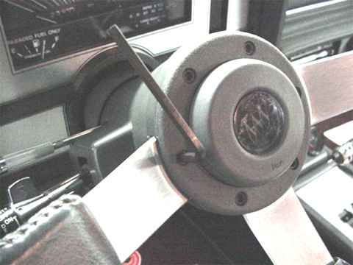 | 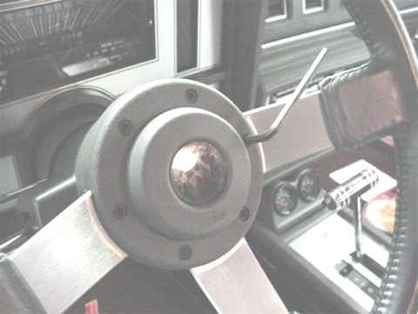

- The horn assembly is now free of the steering wheel EXCEPT for the horn wire. Gently twist the connector going into the steering wheel to the left and the assembly can now be removed from the car.

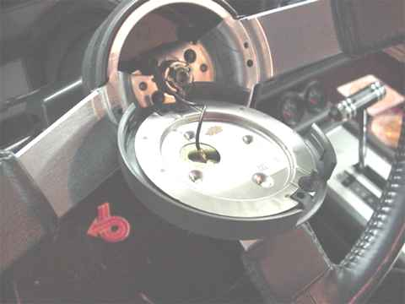 | 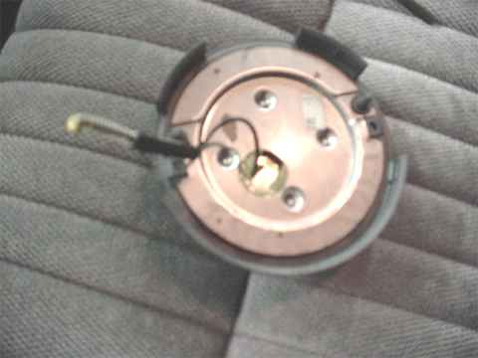

- We recommend heating up the rubber part of the assembly that the horn button is seated into to make removal easier. Use a hair dryer and be careful not to overheat and melt the rubber. You just want to warm it up a bit to make the rubber more flexible. Push down on the lower edge of the rubber center where the horn symbol is and you should be able to get a small screwdriver under the button to help start prying it out.

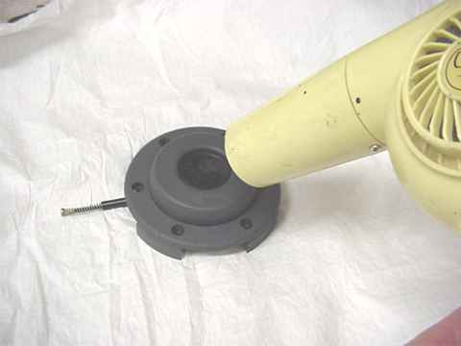 | 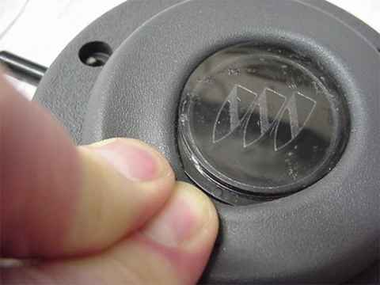

- Be careful using the screwdriver, you do not want to puncture the rubber cushion. You just want to pry up enough to get your fingers under the button to pry it out by hand. Once the button is removed you will see a small notch. (see pic below on lower right) This notch is to ensure that the button is installed correctly in relation to the horn symbol in the rubber cushion.

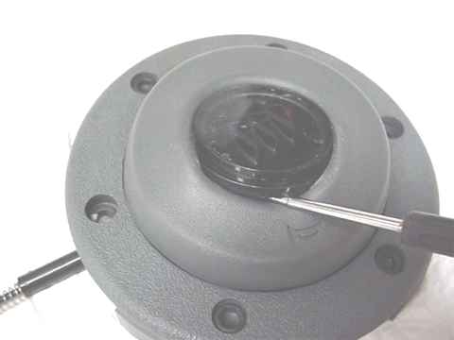 | 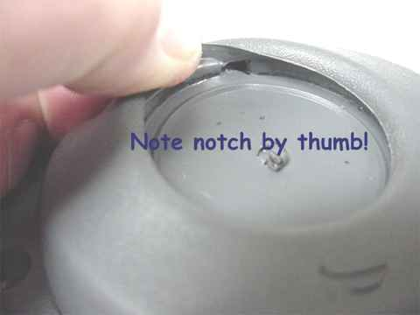

- Now you are ready to install our horn button. You may want to heat up the rubber cushion before inserting the new button. Line up the small square piece that juts out at the top of the horn button with the locating notch in the rubber cushion. Gently work the button into the groove with the screwdriver using great care not to put the screwdriver up against the button as you may mar the edges!

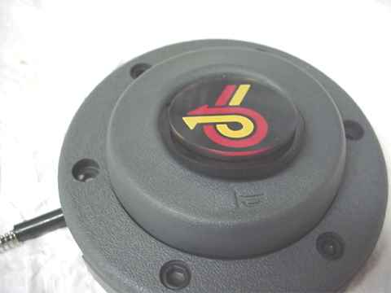 | 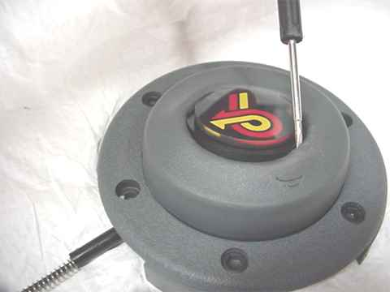

- Make sure button is fully seated in the rubber cushion. You are now ready to install the completed assembly back on the steering wheel. Push the horn wire in the receptacle in the steering wheel and gently twist to the right until locked. Install the two allen bolts you removed earlier. CAUTION! Do NOT overtighten these bolts or you may end up cracking the outer horn ring! Just snug should be good enough. The button should be cleaned only with a soft rag as it may scratch easily. Test your horn and you are done!

